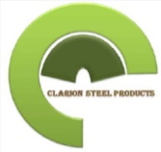

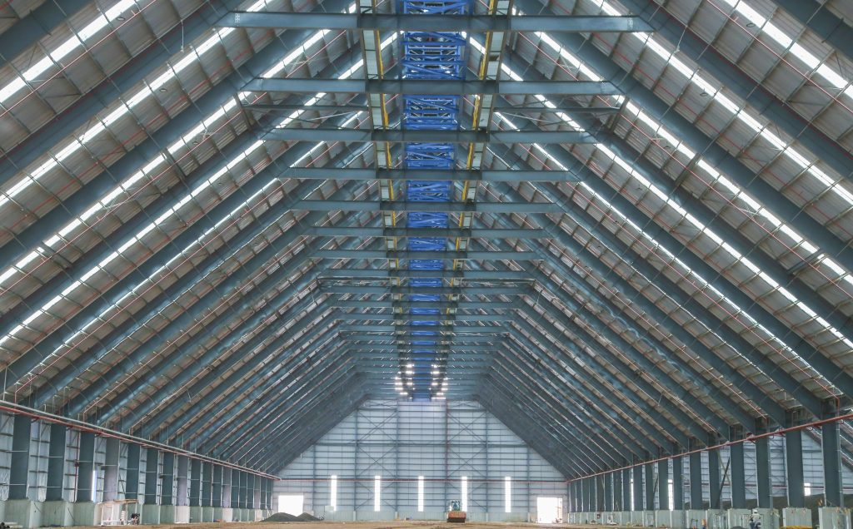
COMPANY PROFILE

Global Partnership I Cost Effectiveness I Local Content

……………..your reliable service provider

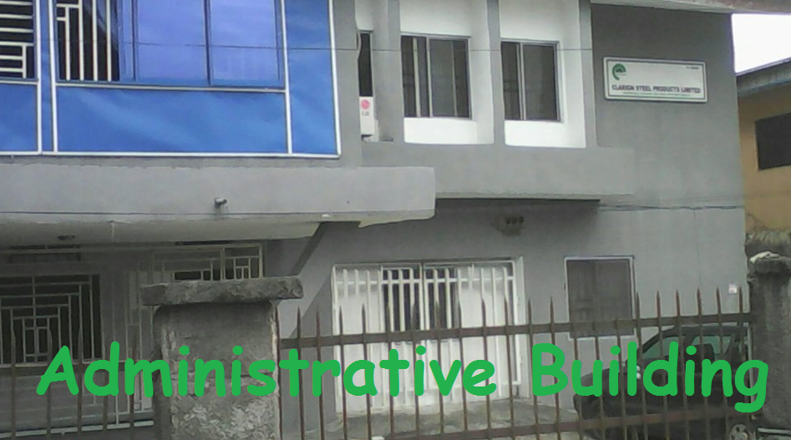
About US
Clarion Steel Products Limited is a limited liability company incorporated in 2014 as an Integrated Engineering firm in Nigeria.

We are engage in Engineering Design, Manufacturing, Construction, Maintenance, Procurement and Installation to clients which include: Oil and Gas, Government, Industries, Corporate Organizations etc

It was established primarily to meet the African Market in the areas of Construction and Project Supports. It’s a subsidiary of CLARION STEEL PRODUCTS GROUP with its corporate office in Nigeria.

Since 2014, it has grown her capital and assets base which is due to our service delivery strategy, driven by our strong organizational capabilities, comprising top-flight management team and dedicated workforce with colossal professional experience. We strongly believe in local content driven by global partnership for effective service delivery.
We built our knowledge-base through the experience of the personnel, who have served in the Construction industry for over 30 years continuously and have the knowledge base of all designing, construction, maintenance and installation services.
Clarion Steel Products also strives to improve on current best practices, and provide innovative solutions to new or unique problems whenever the challenge arises. Our competitive advantages have stimulated our investment growth which includes: Cost- Effectiveness, Technology, Global Partnership, Local Content, Organizational Capability, Access to credit facility etc.
As a company in recognition of the importance of Quality, Health, Safety and the Environment, we are fully committed in the implementation of our QAQC & HSE Policies under the direct supervision of the Managing Director while the Project team efforts is targeted to monitor and deliver projects as demanded by clients and the Management team from time to time carry on fastidious efforts to hire adequate personnel and train existing staff in order to preserve our outstanding level of quality.
Vision

To become a model company that provides services of first choice. Our aim is to provide first class services in the Oil and Gas, Construction, Telecommunications and Marine Industries
Mission

To provide excellent and comprehensive services to meet our customers’ needs in a friendly and corporate environment and to deliver unrivalled quality and unique solutions that will yield optimal value at the least cost by qualified, experienced and highly motivated personnel using the best technology available.

